Digital Communications Assignment

Student Name
Professor
Module

Submission Date

Question 1
NO. The receiver will not detect the error that has occurred this is because being given that its an even parity checker for error detection, the parity check bit (added extra bit) would only detect an inversion of an odd number of bits.
Working.
$1 0 1 0 1 0 1 0; 1 0 0 1 1 0 1 0$
From the above illustration we can clearly observe that that the words (bits) in bold have been reversed. The number of reversed words being equivalent to two, the single bit even parity check can’t work since it only works when the value of the changed word is odd.

Question 2
- The frequency range of line of sight (L.O.S) lies between 1 Megahertz to 30 Megahertz, beyond which neither ground nor skip wave propagation is able to function. Ground wave propagation is permissible for operations of frequencies up to a maximum of 2 Megahertz.
- The frequency range of UHF band is limited from 300 Megahertz to 3 Gigahertz for a wavelength ranging a meter to a decimeter whilst the frequency range lies between 300 Megahertz up to 1 Gigahertz for wavelength ranging a meter to a decimeter.
- Working.
$36\sin{(2π300+{10}^{0}})=36\sin{(wt+{10}^{0})}$
$$The maximum value \left(peak value\right)=36 equivalent to the amplitude$$
$$Rms value is \frac{36}{√2}=18√2$$
$$The phase angle is expressed as {10}^{0}$$
$$The phasor representation is thus obtained as RMS∠PHASE ANGLE$$
$$Phasorial representation is thus 18\sqrt{2} ∠ {10}^{0}$$
Question 3
The waveform represents a physically realizable waveform because
- The waveform has a finite duration (since it decays towards zero before infinite time
- The waveform contains significant non zero values for the defined time interval
- The waveform contains only real values as per the representation $Re\left(a±jb\right), b=0.$
- The waveform exhibits a finite peak i.e. from $+1 to-1$.
Question 4.
Working.
From the truth table of an XOR gate function

X |  | Y | Z (Output)
0 |  | 0 | 0
0 |  | 1 | 1
1 | 0 |  | 1
1 | 1 |  | 0

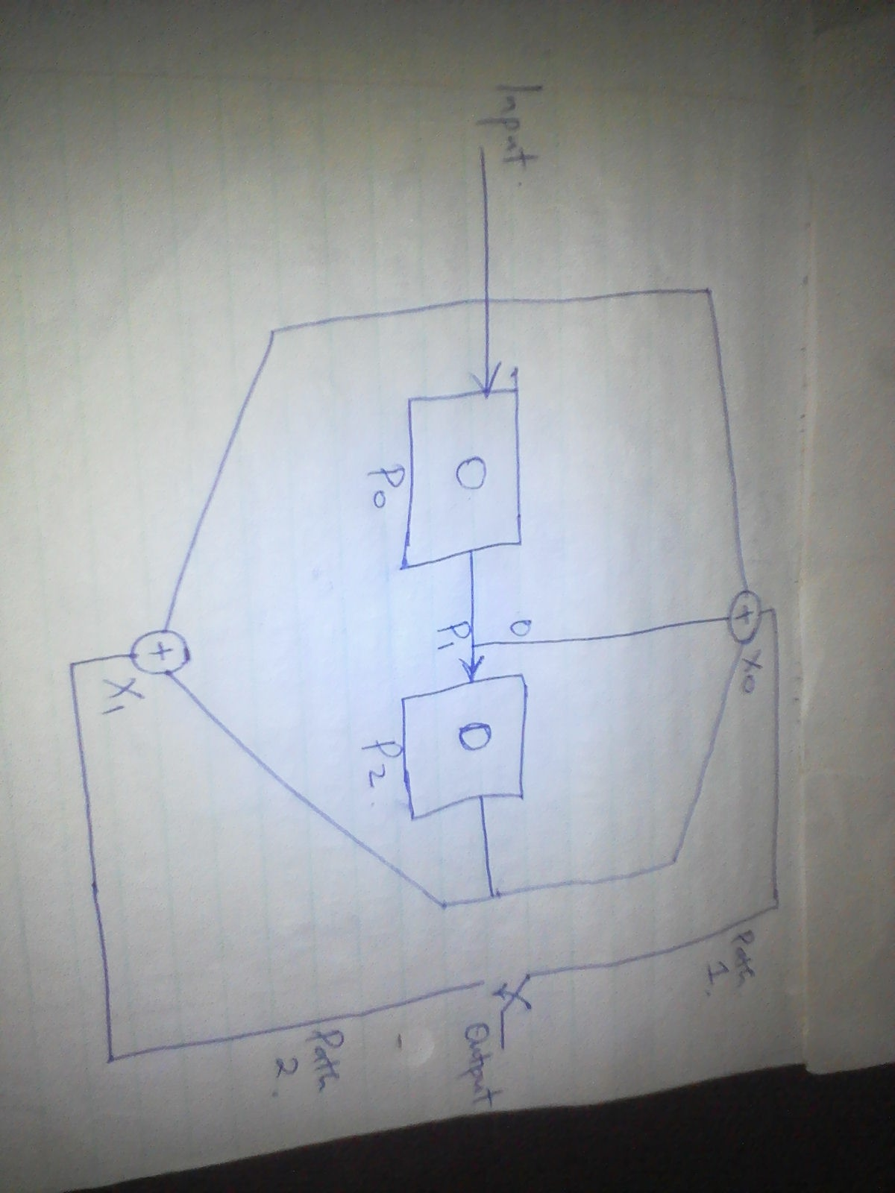

The input is of the order $1 1 0 1$ since the leftmost bit is coming in first.
Input | Po | P1 | P2 | Xo | X1
0 | 0 | 0 | 0 | 0 | 0
1 | 1 | 0 | 0 | 1 | 1
01 | 0 | 1 | 0 | 1 | 0
101 | 1 | 0 | 1 | 0 | 0
1101 | 1 | 1 | 0 | 0 | 1
$$X0=P0⊕P1⊕P2; X1=PO⊕P2$$

The output will thus be $0 0 1 1 1 0 0 0 0 1.$

